**ASSIGNMENT II Solution**

**Name: Debasis Mohanty**

**Roll No. :UEBA19001**

**Q1.** A young couple, Eve and Steven, want to divide their main mandatory household chores (marketing, cooking, dishwashing, and laundering) between them so that each has two tasks but the total time they spend on household duties is kept to a minimum. Their efficiencies on these tasks differ, where the time each would need to perform the task is given by the following table:

(a) Formulate an appropriate OR model for this problem.

(b) Use the computer to solve this model.

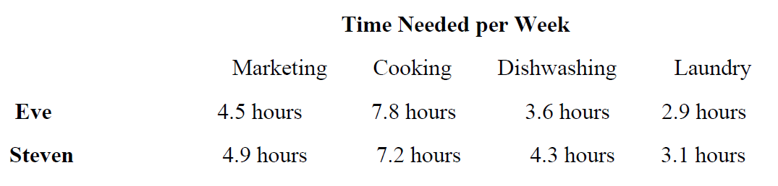

**Ans 1:**

**Goal :** Minimize the time while ensuring that the any two-task assigned either to Eve or Steven can be done with maximum efficiency.

**Decision Variables:** As there are different task to be done. Eve and Steven need to decide on which of these tasks they are good at and then assign it between themselves.

Let

$$M_{Eve}=1 if Eve does marketing$$

$$0 otherwise$$

$$M_{Steven}=1 if Steven does marketing$$

$$0 otherwise$$

**Objective Function:**

$$Min Z= 4.5M_{Eve}+4.9M_{Steven}+7.8C_{Eve}+7.2C_{Steven}+3.6D_{Eve}+4.3D_{Steven}+2.9L_{Eve}+3.1L_{Steven}$$

**Subject to below constraints:**

$$M_{Eve}+ C_{Eve}+D_{Eve}+L_{Eve}=2$$

$$M_{Steven}+C_{Steven}+D_{Steven}+L_{Steven}=2$$

$$M_{Eve}+M_{Steven}=1$$

$$C_{Eve}+C_{Steven}=1$$

$$D_{Eve}+D_{Steven}=1$$

$$L_{Eve}+L_{Steven}=1$$

**Assumptions:**

**It is assumed that Eve and Steven should be available to do the respective assigned household chores**

**Solving it using R using lpSolve we have the below result:**

> Z = lp("min", f.obj, f.con, f.dir, f.rhs, all.bin = TRUE)

> Z

Success: the objective function is 18.4

>

> # Variables final values

> Z$solution

[1] 1 0 0 1 1 0 0 1

**Thus, $M_{Eve}=1, C_{Steven}=1, D_{Eve}=1 and L_{Steven}=1$** .

So, Marketing is assigned to Eve,

Cooking is assigned to Steven,

Dishwashing is assigned to Eve and

Laundry is assigned to Steven to minimize the time required. Total Time required is 18.4 hours.

**Q2.** Northeastern Airlines is considering the purchase of new long-, medium-, and short-range jet passenger airplanes. The purchase price would be $67 million for each long-range plane, $50 million for each medium-range plane, and $35 million for each short-range plane. The board of directors has authorized a maximum commitment of $1.5 billion for these purchases. Regardless of which airplanes are purchased, air travel of all distances is expected to be sufficiently large that these planes would be utilized at essentially maximum capacity. It is estimated that the net annual profit (after capital recovery costs are subtracted) would be $4.2 million per long-range plane, $3 million per medium-range plane, and $2.3 million per short-range plane. It is predicted that enough trained pilots will be available to the company to crew 30 new airplanes. If only short-range planes were purchased, the maintenance facilities would be able to handle 40 new planes. However, each medium-range plane is equivalent to 1 1/3 short-range planes, and each long-range plane is equivalent to 1 2/3 short-range planes in terms of their use of the maintenance facilities. The information given here was obtained by a preliminary analysis of the problem. A more detailed analysis will be conducted subsequently. However, using the preceding data as a first approximation, management wishes to know how many planes of each type should be purchased to maximize profit.

(a) Formulate an OR model for this problem.

(b) Use the computer to solve this problem.

**Ans 2:**

**Goal :** Maximizing profit while ensuring total available resources is not exceeded

**Decision Variable:**

Let $x_{1} be the number of long range jet planes$

$$x_{2} be the number of medium range jet planes$$

$$x_{3} be the number of short range jet planes$$

**Objective Function:**

$$Max Z=4.2x_{1}+3x_{2}+2.3x_{3}$$

**Subject to the below constraints:**

$$67x_{1}+50x_{2}+35x_{3}≤1500 (Authorized Maximum Purchase)$$

$$x_{1}+x_{2}+x_{3}≤30 (Crew Member)$$

$$\frac{5}{3}x_{1}+\frac{4}{3}x_{2}+x_{3}≤40 (Maintenance Facilities)$$

$$x_{1} ,x_{2} ,x_{3}≥0$$

$$x_{1} ,x_{2} ,x_{3}=integer as planes can^{'}t be bought in fractions$$

**Assumptions: Resources required to construct plane is infinite unless and until the demand is fulfilled.**

$$The number of plane will be an integer as planes can^{'}t be bought in fractions$$

**Solving it using R using lpSolve we have the below result:**

> Z

Success: the objective function is 95.71875

>

> # Variables final values

> Z$solution

[1] 14.0625 0.0000 15.9375

**Thus, we should buy 14 long-range jet planes, 0 medium-range jet planes and 16 short-range jet planes to maximize our profit adhering to all resource constraints. Maximum profit is $95.7 million.**

**Q3.** XYZ company is planning to build several warehouses for storing packets of noodles. These warehouses would serve two major customers with monthly demands of 300 and 500 units. Three candidate warehouses with capacities 400, 500, and 600 can be constructed. Using the estimated construction costs of the warehouses, their useful life and time value of money, the construction cost per month for three warehouses is estimated as $800, $1200 and $700. The unit transportation cost from the three candidate warehouses to the customers is given in the table below. Formulate an OR model to determine which warehouses to construct and the corresponding shipping pattern.

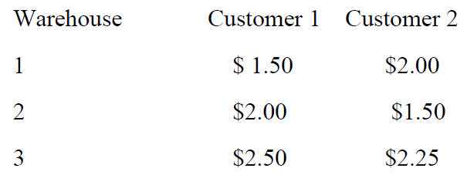

**Ans 3:**

**Goal:** Minimize the cost of warehouse construction along with the transportation cost ensuring the total available supply is not exceeded and the total demand is fulfilled.

**Decision Variable:**

Let

$$W_{i}=1 if i^{th} warehouse is constructed$$

$W_{i}=0 if i^{th} warehouse is not constructed$, $where i=1,2, 3$

$$x_{ij}=number packets of noodles, if i^{th} warehouse is assigned to j^{th}customer$$

$x_{ij}=0, if i^{th} warehouse is not assigned to j^{th}customer$

It is necessary that only if a warehouse is constructed then only it is assigned to a customer

$$i.e if W_{i}=1 then x_{ij}≠0$$

**Objective Function:**

$$Min Z=800 W_{1}+1200 W_{2}+700 W_{3}+1.5 W_{1}x_{11}+2W_{1}x_{12}+ 2 W_{2}x_{21}+2W_{2}x_{22}+ 2.5 W_{3}x_{31}+2.25W_{3}x_{32}$$

**Subject to the below constraints:**

**Demand Constraints**

$$1.5 W_{1}x_{11}+ 2 W_{2}x_{21}+2.5 W_{3}x_{31}≥300$$

$2W_{1}x_{12}+2W_{2}x_{22}+ 2.25W_{3}x_{32}≥500$

**Supply Constraints**

$$1.5 W_{1}x_{11}+2W_{1}x_{12}≤400$$

$$2 W_{2}x_{21}+2W_{2}x_{22}≤500$$

$$2.5 W_{3}x_{31}+2.25W_{3}x_{32}≤600$$

$$x_{ij}= integer as noodle packets can^{'}t be sold in fractions$$

**Assumptions:**

**Market is infinite. Whatever is produced is sold.**